1. Create a Restful API using spring mvc as per the requirements below: (should use MongoDB)

The application should display a Form in the landing page (index. Page) where the user can enter the ‘Employee’ details like ‘Employee ID’, ‘Employee Name’, ‘Employee Email’ and ‘Location’ and upon submission the data should be saved onto a database table.

Result;

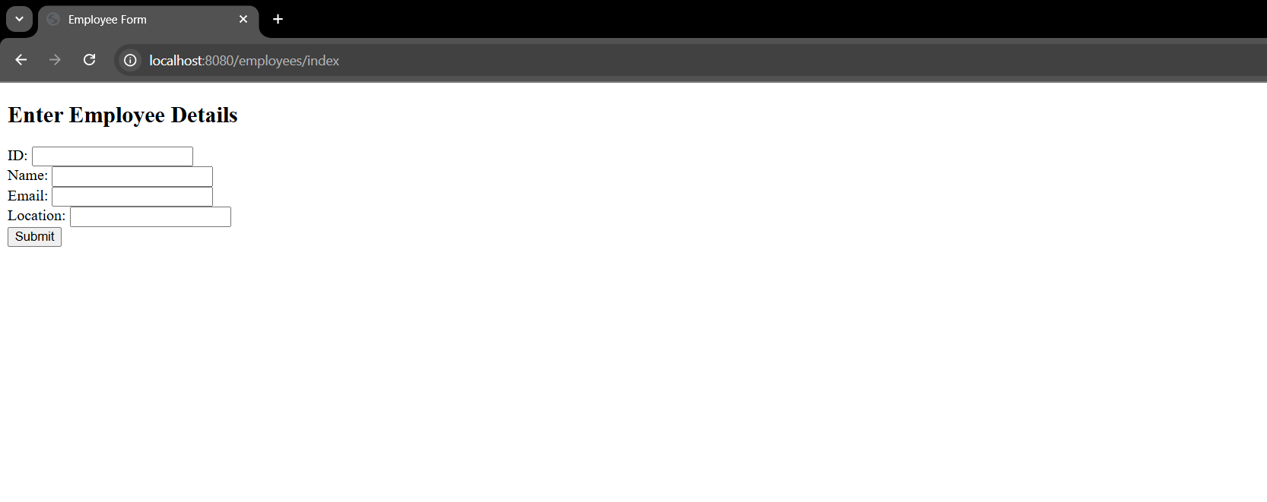

The application should also support a ‘/displayAll’ path which shows the list of all the Employees.

Result;

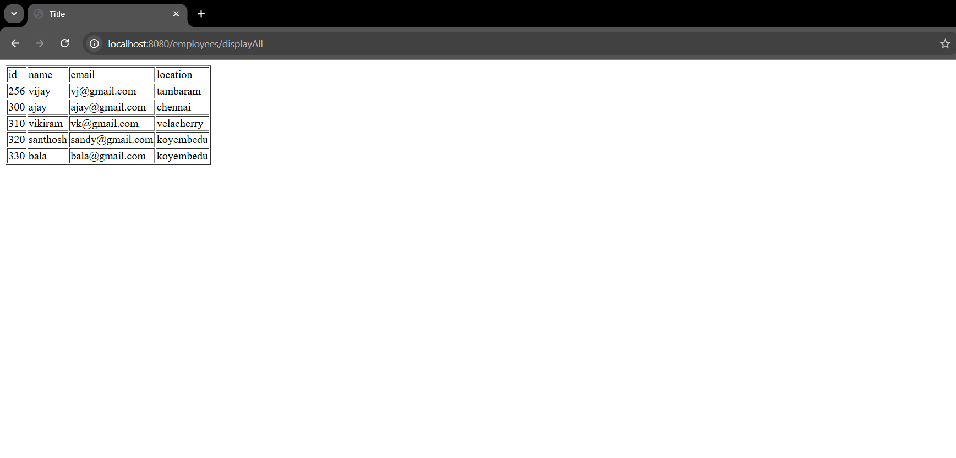

The application should also support a ‘/display/<user id>’ path where upon passing of userid as the parameter the details of only the particular Employee holding that Employee ID will be displayed.

Result;

